HOW TO:
Step 1.
Visit https://www.ytf.org.za/


Click “Join Yoga Teachers Fellowship”

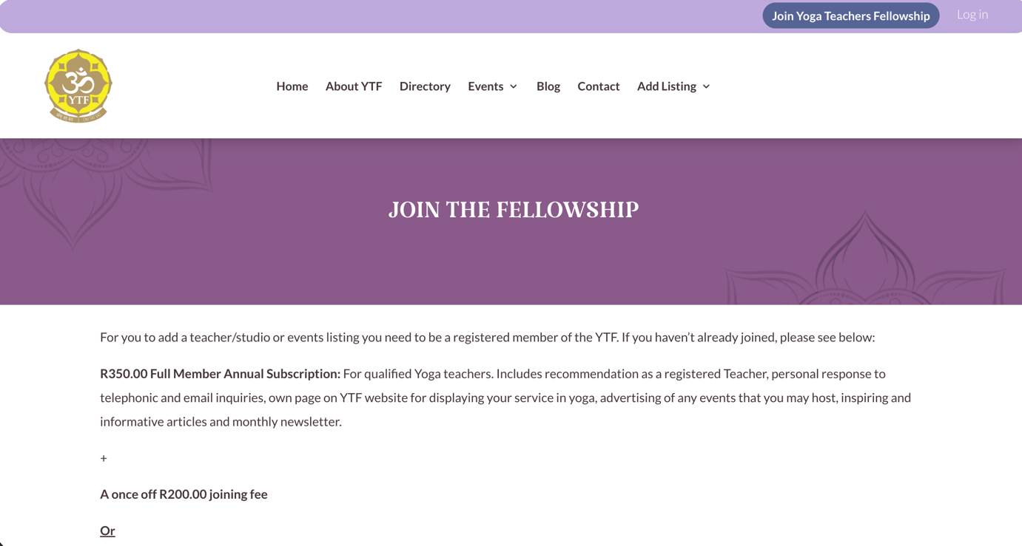

Scroll down:
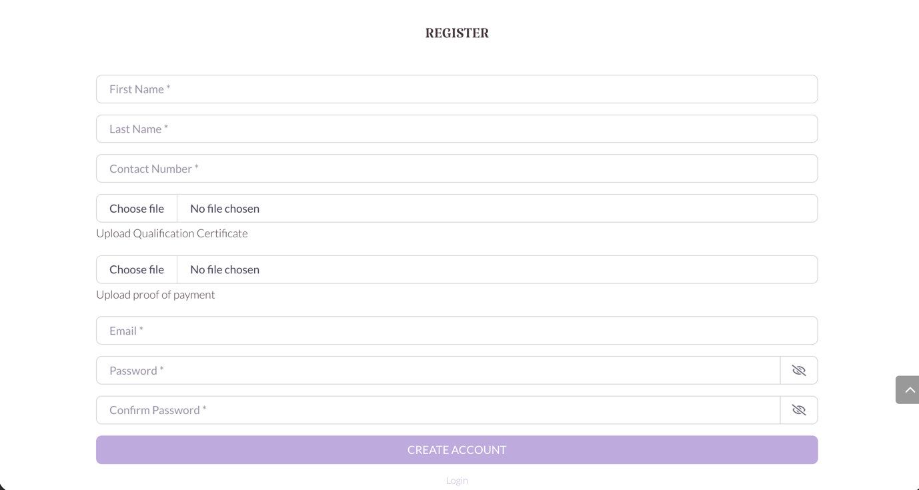

Fill in the registration form.
*IF YOU ARE ALREADY A PAID UP MEMBER THERE IS NO NEED TO SDD YOUR CERTIFICATE OR POP.

Click “CREATE ACCOUNT”

Your account will be pending until YTF approves your account. Please be patient as we see to all the requests within 72hrs. You will receive an email confirming your account has been approved. You may then login:

Step 2.
Visit https://www.ytf.org.za/
Click on Log in

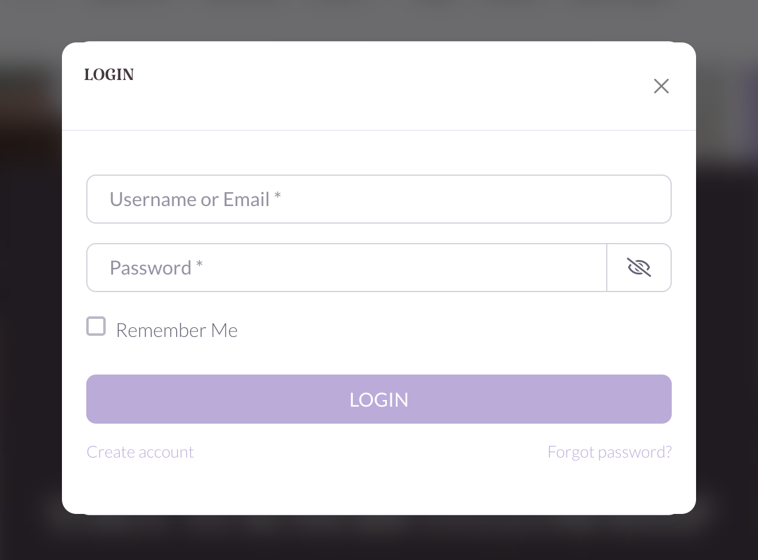

Type in username and password. You will be redirected to the add listing page:

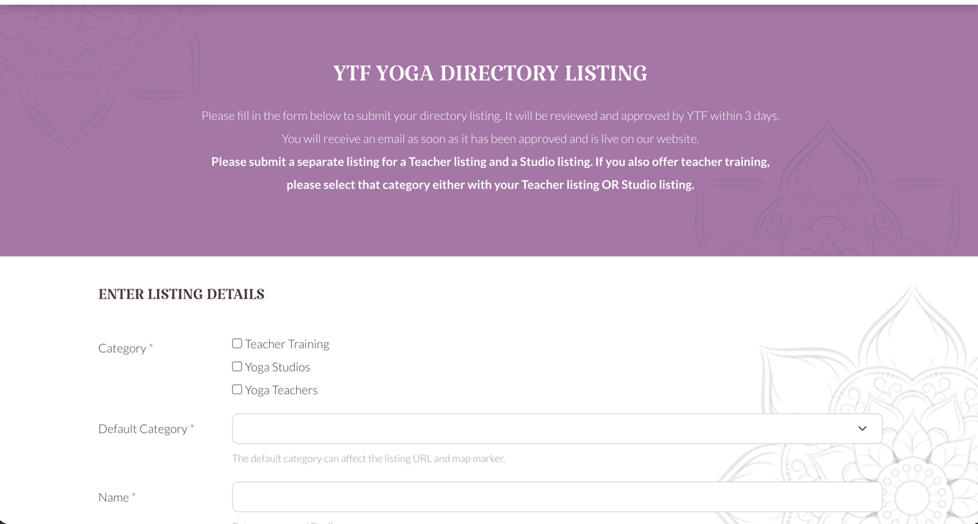

Fill in the form.
*IMPORTANT: Please submit a separate listing for a Teacher listing and a Studio listing. If you also offer teacher training, please select that category either with your Teacher listing OR Studio listing. Ensure you select either Teacher or Studio as the default listing.



You may select yoga styles already present from the drop down list or add additional ones, ensure you separate with a comma.

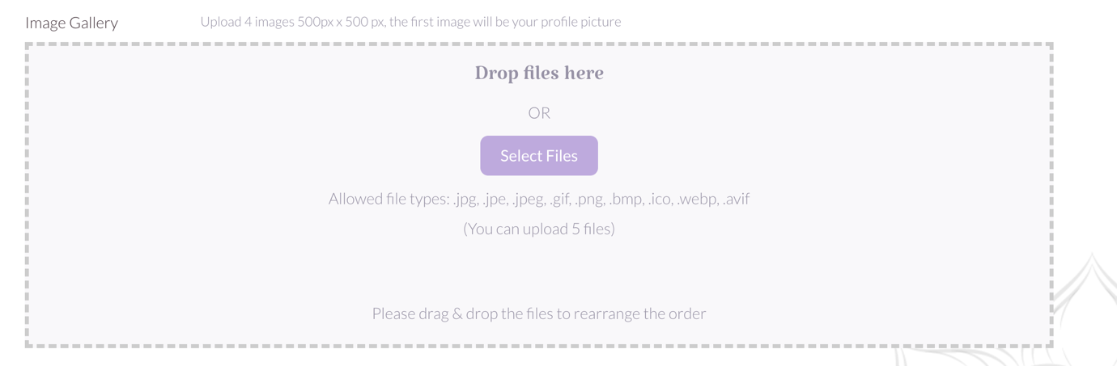

Please ensure images are 500px x 500px.
The 1st image will be your profile picture

Sample Listing:
